- Define Computer Networks. Explain local area network in detail with a neat diagram.
Ans:
A computer network is a system where two or more computing devices are interconnected to share data, resources, and information. These devices, known as nodes, can communicate with each other using either wired or wireless media. The primary purpose of a network is to enable resource sharing, efficient communication, and centralized data management.
Local Area Network (LAN): A LAN is a network that connects computers and
devices within a small geographical area, such as a home, office, or campus.
Characteristics:
• Covers a limited area.
• High data transfer rates (up to 10 Gbps).
• Typically owned and managed by a single organization.
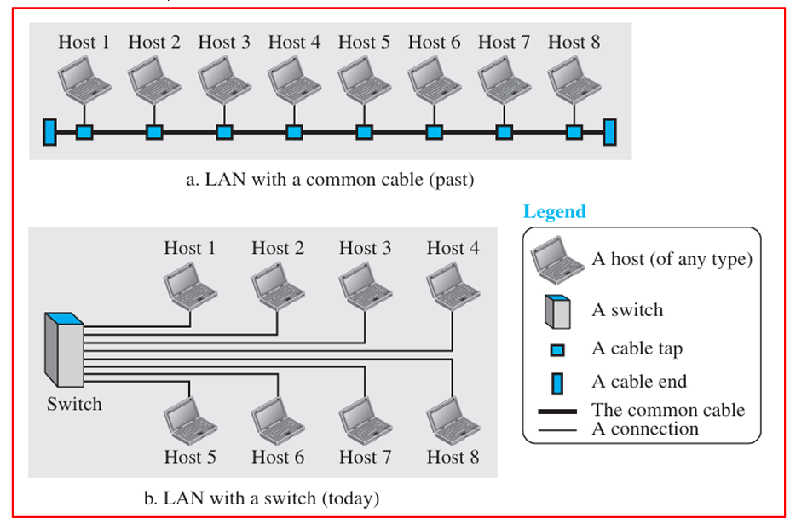
Examples: Ethernet networks, Wi-Fi networks in homes and small offices.

Figure 1.8: An isolated LAN in the past and today

LAN Setup:
• Common Cable Connection: In the past, all hosts within a Local Area Network (LAN) were connected via a single common cable.
o Packet Transmission: When one host sent a packet to another, it was broadcast to all hosts on the network.
o Packet Filtering: The intended recipient would accept the packet, while all other hosts would drop it.
o Drawback: This method created significant network congestion, as every packet was visible to all hosts, even when they weren't the intended recipient.
Modern LAN Setup:
• Switch-Based LAN: Today, most LANs use smart switches to handle packet delivery.
o Address Recognition: A switch is intelligent enough to recognize the destination address of each packet.
o Selective Packet Forwarding: Instead of broadcasting packets to all hosts, the switch sends the packet directly to the destination host.
o Benefits:
♣ Reduced Traffic: Since packets are only sent to the intended recipient, overall network traffic is significantly reduced.
♣ Simultaneous Communication: More than one pair of hosts can communicate simultaneously as long as they have different source and destination addresses. This improves network efficiency.
LAN Capacity:
• Flexibility: The term "LAN" does not specify any constraints on the number of hosts. A LAN can accommodate a wide range of host numbers, depending on the network’s size and structure.
- List and explain design issues for layer.
Ans: Protocol layering is a design principle in computer networks where communication tasks are broken down into multiple layers. Each layer performs a specific function, and the layers work together to enable communication between devices over a network.

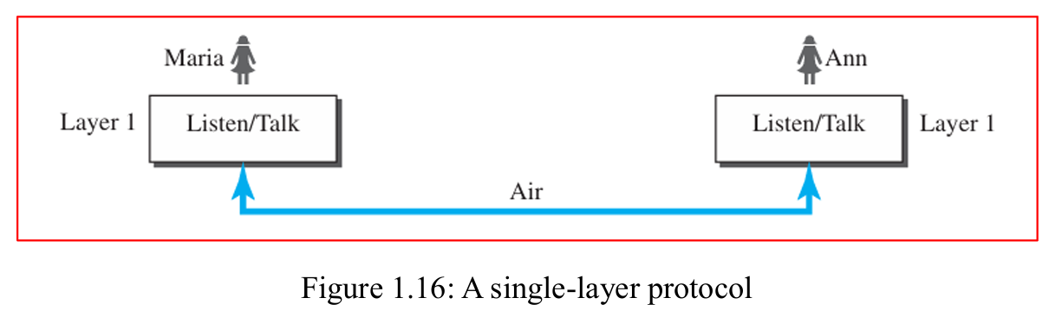
4.1. Scenarios
First Scenario: Simple Communication in One Layer
In the first scenario, communication is straightforward and occurs in a single layer. Imagine Maria and Ann, who are neighbors and share many common interests. Their interaction happens face-to face, in the same language, as depicted in Figure 1.16. Despite its simplicity, certain rules govern their communication.
Second Scenario: A three-layer protocol
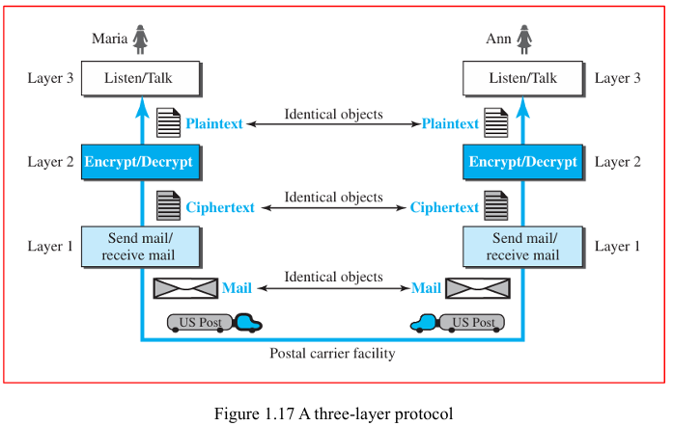
In this scenario, Ann is offered a promotion requiring her to relocate far from her friend Maria. Despite the distance, they wish to continue their communication to collaborate on an innovative project for their future retirement business. To maintain the confidentiality of their exchange, they decide to use a secure encryption/decryption technique. This technique ensures that their letters remain unreadable to unauthorized individuals.

The communication between Ann and Maria can be visualized as taking place in three distinct layers:

1. Third Layer (Plaintext Creation): Maria speaks to the third-layer machine, which listens and generates the plaintext (the original letter). This plaintext is then handed over to the second-layer machine.
2. Second Layer (Encryption/Decryption): The second-layer machine encrypts the plaintext, creating ciphertext (the encrypted letter). This ciphertext is then passed to the first-layer machine.
3. First Layer (Mailing): The first-layer machine puts the ciphertext in an envelope, adds the sender's and receiver's addresses, and mails it.
Protocol layering is useful in various scenarios, such as:
• Data transmission over the internet where multiple types of data (emails, videos, web pages) are transmitted using different protocols at each layer.
• Device communication between a computer and a printer, where layered protocols manage data transfer and error detection.
• Telecommunication systems, where layered protocols ensure voice signals are transmitted efficiently and correctly.
• Multimedia streaming, where protocols manage data buffering, synchronization, and error correction to deliver seamless audio and video streams.
Advantages of Protocol Layering:
1. Modularity: Each layer is independent, allowing for changes in one layer without affecting others. For example, if Ann and Maria decide that the encryption needs to be upgraded, they can replace only the second-layer machine without altering the other layers.
2. Service Separation: Protocol layering separates the services from their implementation. Maria could perform the tasks of the first layer herself if needed, as long as she provides the required services.
3. Intermediate Systems: In more complex networks, intermediate systems only need to handle specific layers, making the overall system less complex and less expensive.
Disadvantages of Protocol Layering:
1. Complexity in Layer Integration: While modularity offers flexibility, it can add complexity. A single machine performing all tasks could simplify the setup, but if there are issues, the entire system might need to be replaced rather than just one layer.
4.2. Principles of Protocol Layering
First Principle: Bidirectional Communication
To achieve bidirectional communication in protocol layering, each layer must be designed to handle two complementary tasks, one for each direction of communication. For example:
Third Layer: Responsible for listening in one direction and transmitting in the other.
Second Layer: Handles encryption in one direction and decryption in the other.
First Layer: Manages sending and receiving mail.
Each layer must be capable of performing its specific function for both incoming and outgoing data.
Second Principle: Identical Objects
In protocol layering, the objects processed by each layer at both communicating sites must be identical. For instance:
Layer 3: The object should be a plaintext letter at both sites.
Layer 2: The object should be a ciphertext letter at both sites.
Layer 1: The object should be a piece of mail at both sites.
Consistency in the objects at each layer ensures proper communication and processing across different layers.
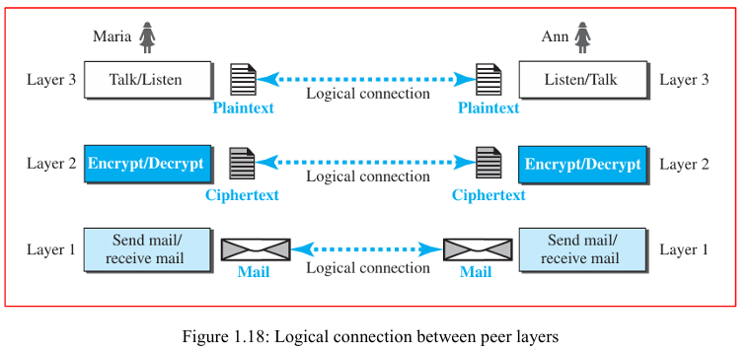
4.3. Logical Connections
This means there is communication from one layer to the next. Imagine that Maria and Ann view each layer as having a logical (or imaginary) connection that allows them to transmit objects created at that layer. Understanding these logical connections will enhance your comprehension of layering in data communication and networking.
In a layered model, logical connections refer to virtual connections established between the same layers in different devices. For example:
• The application layers of two computers communicate as though they are directly connected, even though physical transmission occurs across multiple lower layers.
• Logical connections provide the abstraction necessary to hide the complexities of the underlying transmission methods, giving the appearance that communication occurs at a single layer.
Logical connections ensure that communication protocols at each layer, such as TCP (Transport Layer) or HTTP (Application Layer), interact correctly without the user needing to understand the intricacies of network transmission.

- What are guided transmission media? Explain twisted pair cable in detail.
Ans:
6.1. Guided Media
Guided media are types of communication channels that provide a specific path for signals to travel from one device to another. These include:
1. Twisted-Pair Cable: This type of cable consists of pairs of insulated copper wires twisted together. The twisting helps reduce electromagnetic interference and maintains signal quality.
2. Coaxial Cable: Coaxial cables have a central conductor, an insulating layer, a metallic shield, and an outer insulating layer. This structure helps to protect the signal from interference and allows for high-speed data transmission.
3. Fiber-Optic Cable: Unlike twisted-pair and coaxial cables, fiber-optic cables use light signals to transmit data. They consist of thin strands of glass or plastic that carry light pulses over long distances with minimal signal loss.
6.2. Twisted-Pair Cable
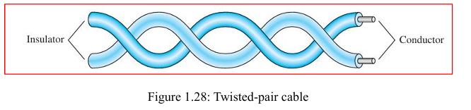
A twisted pair cable consists of two insulated copper conductors twisted together. Each wire in the pair serves a different function: one carries the signal to the receiver, and the other acts as a ground reference. The receiver processes the difference between the two wires to retrieve the signal.
Noise and Interference
Twisted pair cables are designed to minimize the impact of interference (noise) and crosstalk. When the wires are parallel, noise or crosstalk can affect each wire differently due to their varying distances from the sources of interference. By twisting the wires, the cable maintains a balance. In each twist, the relative positions of the wires to the noise source change, helping to ensure that both wires experience similar levels of interference. This twisting reduces the impact of unwanted signals, as the receiver calculates the difference between the wires, canceling out most of the noise.
Shielded vs. Unshielded Twisted-Pair Cables
• Unshielded Twisted-Pair (UTP): The most common type used in communications, UTP cables do not have additional shielding. They are less expensive and less bulky but can be more susceptible to interference.
• Shielded Twisted-Pair (STP): STP cables have an additional metal foil or braided mesh covering each pair of conductors. This shielding reduces interference and improves signal

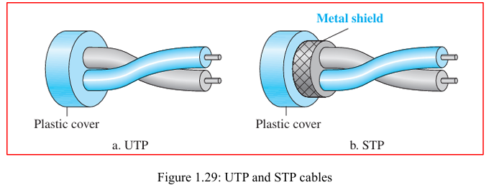
quality but makes the cables bulkier and more costly. STP is primarily used by IBM and is less common outside of their applications.
Categories of UTP Cables
The Electronic Industries Association (EIA) classifies UTP cables into seven categories, with Category 1 being the lowest quality and Category 7 being the highest. Each category is suitable for specific applications, and the standards help ensure the cable meets certain performance criteria.
Connectors
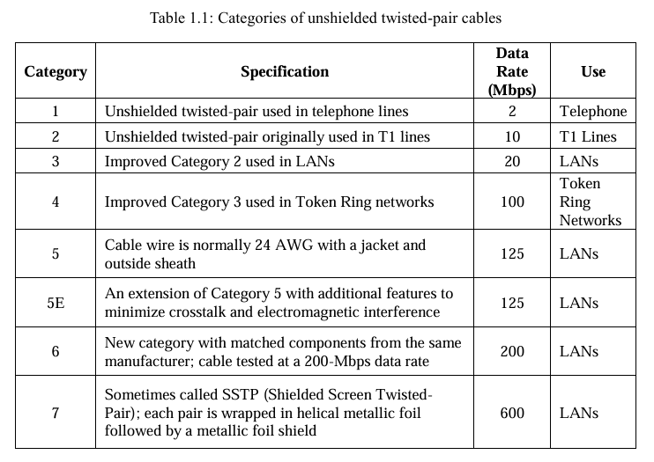
The RJ45 connector is the most common connector for UTP cables. It is a keyed connector, meaning it can only be inserted in one direction, which ensures a proper connection.

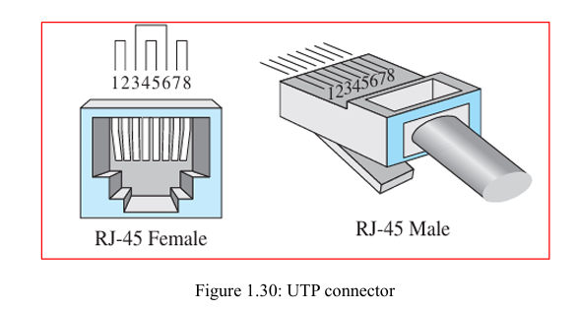
Performance
The performance of twisted-pair cables is often assessed by measuring attenuation (signal loss) in relation to frequency and distance. Although twisted-pair cables can handle a broad range of frequencies, attenuation increases significantly at frequencies above 100 kHz. Attenuation is measured in decibels per kilometer (dB/km), and higher frequencies result in greater signal loss.
Applications
Twisted-pair cables are widely used in various applications:
• Telephone Lines: Used for voice and data transmission in the local loop connecting subscribers to telephone offices.
• DSL Lines: Provide high-data-rate connections by utilizing the high bandwidth of UTP cables.
• Local-Area Networks (LANs): Employed in networks such as 10Base-T and 100Base-T for data transmission.
6.3. Coaxial Cable
Coaxial cable, often referred to as coax, is designed to carry high-frequency signals, unlike twisted pair cables. It consists of the following parts:
• Central Core Conductor: A solid or stranded copper wire, responsible for carrying the signal.
• Insulating Sheath: Surrounds the core conductor, separating it from the outer conductor.
• Outer Conductor: Made of metal foil, braid, or both, which serves two purposes: o Acts as a shield against external noise. o Functions as the second conductor to complete the circuit.
• Additional Insulation: Encases the outer conductor for further protection.
• Plastic Cover: Provides external protection for the entire cable.

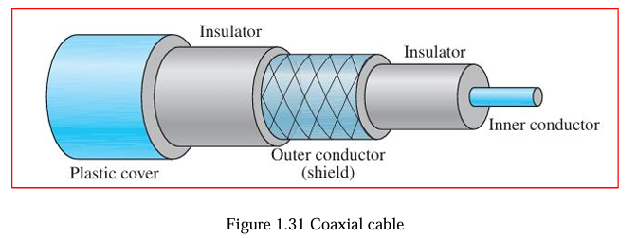
This design helps coaxial cables transmit signals with less interference and at higher frequencies compared to twisted-pair cables.
Coaxial Cable Standards (RG Ratings)
Coaxial cables are classified based on Radio Government (RG) ratings. Each RG number specifies certain physical characteristics of the cable, such as:
• Wire Gauge: Thickness of the inner conductor.
• Insulation: Thickness and material of the inner insulator.
• Shielding: Design and construction of the outer conductor.
• Outer Casing: Size and type of the protective cover.
These RG-rated cables are suited for different specialized applications, as indicated by their specifications.
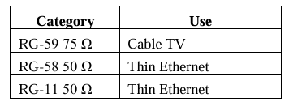
Table 1.2: RG-rated cables are suited for different specialized applications.
Coaxial Cable Connectors
To connect coaxial cables to devices, special connectors are required. The most common connector type is the Bayonet Neill-Concelman (BNC) connector. There are different variations of this connector:
• BNC Connector: Used to connect the cable to a device (e.g., a TV).
• BNC T Connector: Often used in Ethernet networks to split the signal to multiple devices.
• BNC Terminator: Placed at the end of the cable to prevent signal reflection and ensure stable transmission.

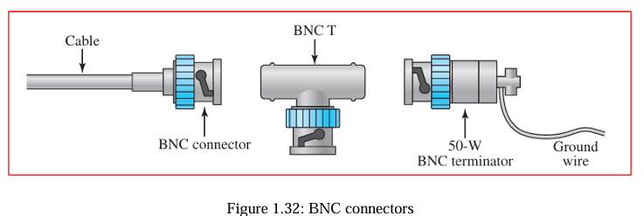
Performance of Coaxial Cables
Coaxial cables provide higher bandwidth compared to twisted-pair cables, allowing them to carry more data. However, their attenuation (signal weakening) is greater, meaning the signal degrades over distance and requires frequent use of repeaters to maintain signal strength.
Applications
• Analog Telephone Networks: Coaxial cables were used to carry large amounts of voice signals, with one cable supporting up to 10,000 voice channels.
• Digital Telephone Networks: Coaxial cables were capable of transmitting digital data at speeds up to 600 Mbps.
Today, fiber optic cables have largely replaced coaxial cables in telephone networks due to their superior performance.
4) Explain TCP/IP reference model with a neat labelled diagram.
Ans:
TCP/IP is the protocol suite widely used for communication on the Internet today. It is a collection of protocols organized into different layers, where each layer handles specific tasks, making it easier to manage complex communication processes. TCP/IP is a hierarchical protocol, meaning that each higher-level protocol depends on the services provided by one or more lower-level protocols. This layered structure ensures efficient and organized communication across networks. However, today, it is more commonly represented as a five-layer model. These layers work together to ensure smooth data transmission over the network.
5.1. Layered Architecture
To understand how the layers in the TCP/IP protocol suite work during communication between two hosts, let's consider a small network composed of three local area networks (LANs), each connected by a link-layer switch. These LANs are also interconnected through a router. Figure 1.20 illustrates this setup.

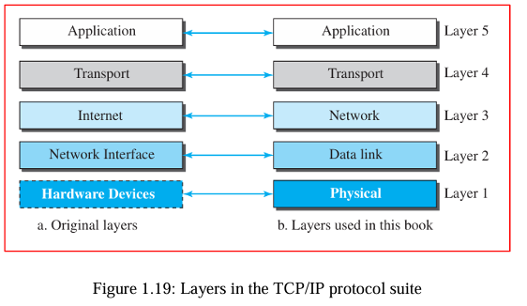
• Application Layer: The source host (Host A) creates a message at the application layer and sends it down through the stack.
• Transport Layer: The message is passed to the transport layer, which ensures reliable delivery.
• Network Layer: At the network layer, the message is encapsulated into packets for transmission across the network.
• Data Link Layer: The packets are then prepared for transmission over the physical network in the data-link layer.
• Physical Layer: Finally, the message is sent through the physical medium (wires, cables, etc.) to reach the destination host
- Explain the characteristics of data communication system
Ans:
The performance of a data communication system relies on four key characteristics: delivery, accuracy, timeliness, and jitter.
1. Delivery: The system must ensure that data reaches the correct destination. Only the intended recipient—whether a device or a user—should receive the data.
2. Accuracy: Data must be transmitted without errors. If data is altered during transmission and not corrected, it becomes unusable.
3. Timeliness: Data must be delivered promptly. Delayed data, especially in applications like video and audio, lose their value. For real-time transmission, data must be delivered in the same sequence and without significant delays.
4. Jitter: Jitter refers to the inconsistency in packet arrival times. Inconsistent delays, such as video packets arriving at varying intervals, can degrade the quality of the audio or video. For instance, if video packets are sent every 30 ms, but some arrive after 40 ms, the video quality will be affected.

- Explain the components of data communication
Ans:
  - Components
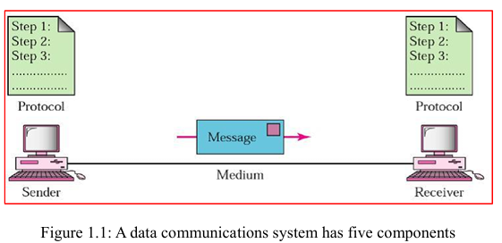
A data communication system includes the following components:

1. Message: The data or information being communicated (e.g., text, images, audio).
2. Sender: The device that sends the message, such as a computer or smartphone.
3. Receiver: The device that receives the message, like another computer or a printer.
4. Transmission Medium: The physical path through which the data is transmitted, like cables or radio waves.
5. Protocol: A set of rules that governs the communication between devices to ensure proper data exchange.
The performance of a data communication system relies on four key characteristics: delivery, accuracy, timeliness, and jitter.
1. Delivery: The system must ensure that data reaches the correct destination. Only the intended recipient—whether a device or a user—should receive the data.
2. Accuracy: Data must be transmitted without errors. If data is altered during transmission and not corrected, it becomes unusable.
3. Timeliness: Data must be delivered promptly. Delayed data, especially in applications like video and audio, lose their value. For real-time transmission, data must be delivered in the same sequence and without significant delays.
4. Jitter: Jitter refers to the inconsistency in packet arrival times. Inconsistent delays, such as video packets arriving at varying intervals, can degrade the quality of the audio or video. For instance, if video packets are sent every 30 ms, but some arrive after 40 ms, the video quality will be affected.

- Explain the different types of data flow in data communications
Ans:
Data flow refers to the manner in which data is transmitted between two devices. It can happen in three modes:
1. Simplex: Data flows in one direction only, like a keyboard sending data to a computer (one-way communication).
2. Half-Duplex: Both devices can send and receive data, but not at the same time. For example, a walkie-talkie allows communication in both directions, but one at a time.
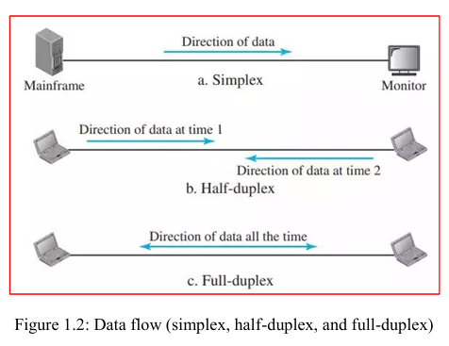
3. Full-Duplex: Both devices can transmit and receive data simultaneously, like in a phone conversation where both parties can speak and listen at the same time.

- Explain the types of networks in data communication
Ans:
NETWORK TYPES
Which is used to connect networks to form an internetwork (a network of networks).
3.1. Local Area Network (LAN)
A LAN is a network that connects computers and devices within a small geographical area, such as a home, office, or campus.
Characteristics:
• Covers a limited area.
• High data transfer rates (up to 10 Gbps).
• Typically owned and managed by a single organization.

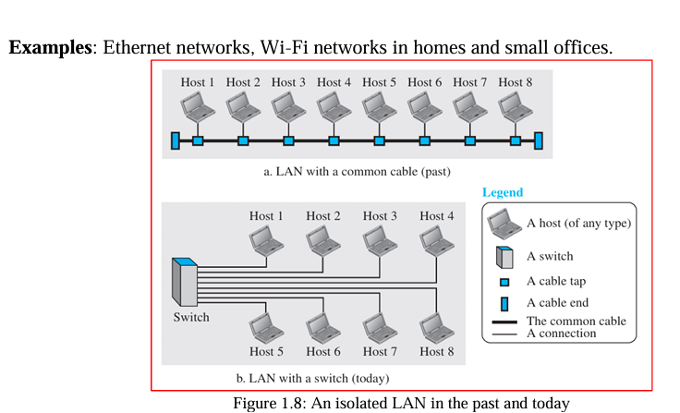
LAN Setup:
• Common Cable Connection: In the past, all hosts within a Local Area Network (LAN) were connected via a single common cable.
o Packet Transmission: When one host sent a packet to another, it was broadcast to all hosts on the network.
o Packet Filtering: The intended recipient would accept the packet, while all other hosts would drop it.
o Drawback: This method created significant network congestion, as every packet was visible to all hosts, even when they weren't the intended recipient.
Modern LAN Setup:
• Switch-Based LAN: Today, most LANs use smart switches to handle packet delivery.
o Address Recognition: A switch is intelligent enough to recognize the destination address of each packet.
o Selective Packet Forwarding: Instead of broadcasting packets to all hosts, the switch sends the packet directly to the destination host.
o Benefits:
♣ Reduced Traffic: Since packets are only sent to the intended recipient, overall network traffic is significantly reduced.
♣ Simultaneous Communication: More than one pair of hosts can communicate simultaneously as long as they have different source and destination addresses. This improves network efficiency.

LAN Capacity:
• Flexibility: The term "LAN" does not specify any constraints on the number of hosts. A LAN can accommodate a wide range of host numbers, depending on the network’s size and structure.
3.2. Wide Area Network (WAN)
A WAN covers a large geographical area, such as a city, country, or even globally. It connects multiple LANs.
Characteristics:
• Slower data transfer rates than LANs.
• Often managed by multiple entities (e.g., ISPs, governments).
• Utilizes routers and public or private communication links.
Examples: The Internet itself is a WAN, Private networks connecting different company branches.
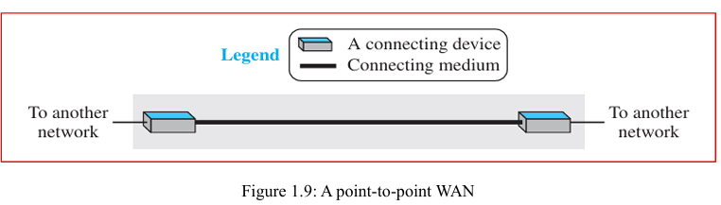
A point-to-point WAN:
A Point-to-Point WAN is a network that connects two communication devices directly via transmission media, such as cables or wireless links. This type of network allows data transmission between just two endpoints, ensuring a dedicated and private communication link. Used by businesses to link branch offices or remote locations.
Transmission Media:
• Cable: Examples include fiber optic, coaxial, or twisted-pair cables.
• Air: Wireless links like microwave or satellite connections.
Advantages:
• Dedicated Line: Since only two devices share the link, there is minimal congestion and consistent bandwidth.
• Security: Limited exposure to external devices reduces the risk of unauthorized access.
A switched WAN:
A switched Wide Area Network (WAN) is a network infrastructure with multiple endpoints that are interconnected. Unlike traditional point-to-point WANs, which only connect two endpoints, a switched WAN allows for dynamic routing between several nodes through switches.
Role in Global Communication: Switched WANs are fundamental in the backbone of modern global communication systems, facilitating data transfer across vast geographical areas.
• A switched WAN is scalable and can connect many endpoints.
• The switches in the network are responsible for choosing the best path for data to travel.
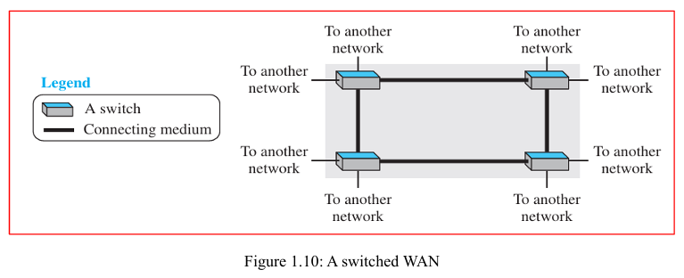
• It is commonly used in large-scale, high-traffic networks like the internet.
Internetwork
In modern networks, it's uncommon to find a LAN (Local Area Network) or WAN (Wide Area Network) operating independently. Instead, they are often connected. When two or more networks connect, they form an internetwork, or internet.
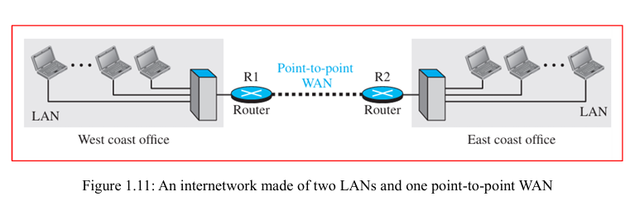
For example, imagine a company with offices on the east and west coasts. Each office has a LAN where employees can communicate within the office. To allow communication between employees at both locations, the company leases a dedicated WAN connection from a service provider. This WAN links the two LANs, creating an internetwork, or a private internet. Now, employees from both offices can communicate with each other
A heterogeneous network
A heterogeneous network is a system that connects various types of devices and network architectures. The term "heterogeneous" signifies diversity in the types of networks, which may include different hardware, operating systems, and communication protocols. When combining WANs and LANs into a heterogeneous network, the WANs provide the backbone for long-distance communication, while the LANs allow for local connectivity.
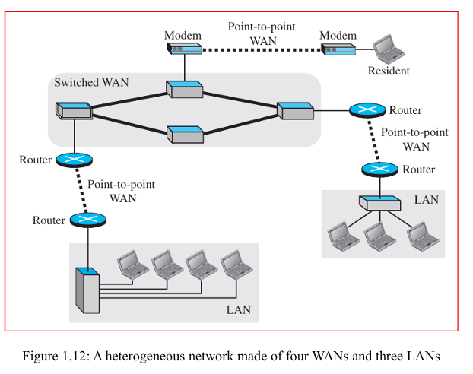
- Explain the types of connections in data communication
Ans:
Type of Connection:
o Point-to-Point: A direct link between two devices, providing the full capacity of the link for communication (e.g., remote control to TV).
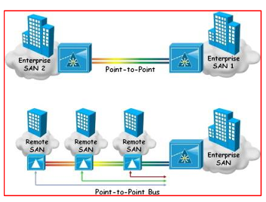
o Multipoint (Multidrop): Multiple devices share a single link, either spatially (simultaneous use) or temporally (taking turns).
Figure 1.3: Types of connections: point-to-point and multipoint

- Explain the types of network topologies in computer networks
Ans: Physical Topology: Refers to how devices are physically arranged in a network. Four main topologies include:
o Mesh Topology:
♣ Every device is connected to every other device, requiring n(n−1)/2 links for n devices.
♣ Node 1 must be connected to n – 1 nodes, node 2 must be connected to n – 1 nodes, and finally node n must be connected to n – 1 nodes. We need n (n – 1) physical links. However, if each physical link allows communication in both directions (duplex mode), we can divide the number of links by 2. In other words, we can say that in a mesh topology, we need n (n – 1) / 2 duplex-mode links.
♣ Advantages: Dedicated links, fault isolation, robust, secure.
♣ Disadvantages: Expensive, complex installation, excessive cabling.
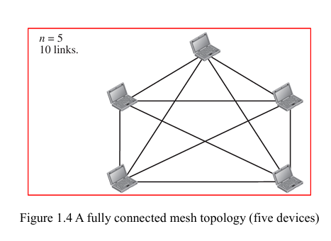
♣ Example: Telephone networks between regional offices.
o Star Topology:
♣ Each device is connected to a central hub, which manages communication.
♣ Advantages: Easy installation and fault isolation; if a link fails, only that device is affected.
♣ Disadvantages: Entire system fails if the hub goes down.
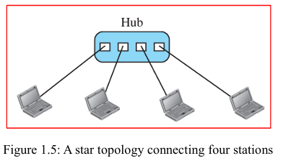
♣ Common in local area networks (LANs).
o Bus Topology:
♣ All devices are connected to a single backbone cable.
♣ Advantages: Easy installation, less cabling than mesh.
♣ Disadvantages: Difficult to add devices, faults in the backbone disrupt the entire network.
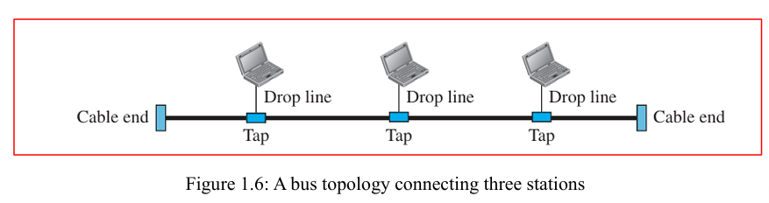
♣ Example: Early Ethernet LANs.

o Ring Topology:
♣ Devices are connected in a loop, with signals traveling in one direction through repeaters.
♣ Advantages: Easy to install, simple fault detection.
♣ Disadvantages: A break in the ring can disable the entire network, though dual rings or switches can mitigate this.
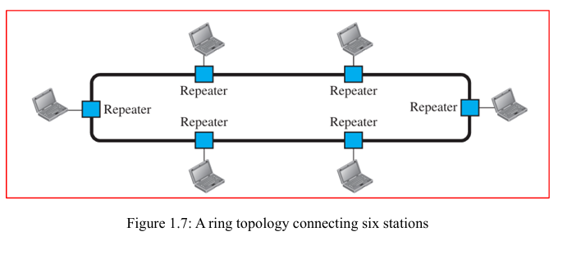
♣ Example: IBM’s Token Ring LANs.

- Explain OSI VS TCP/IP model
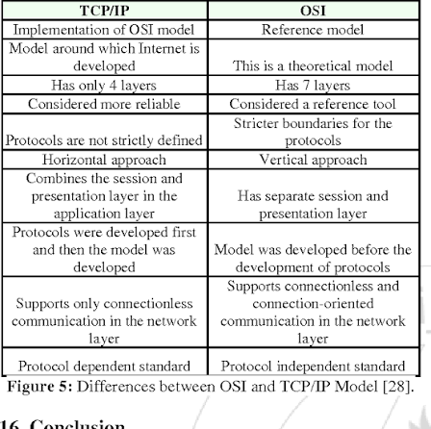
Ans:

- Describe Addressing ? explain OSI model with a neat diagram
Ans:
Addressing in Network
In the context of the Internet and network protocol layering, addressing is a key concept that ensures logical communication between pairs of layers. For any communication between two parties, there must be two essential addresses: a source address and a destination address. Although it might seem like each layer of the protocol model would require a separate pair of addresses, in practice only four are needed, as the physical layer does not use addresses. The physical layer deals with bits, and individual bits do not have addresses.
Addressing at Different Layers
Each layer in the protocol stack uses specific types of addresses, which relate to the type of communication and the name of the data unit used at that layer. Here's a breakdown:
- Application Layer:
o At this layer, addresses are typically names, such as a domain name (e.g., someorg.com) or an email address (e.g., somebody@coldmail.com). These names represent the service or resource being accessed.
o Packet name: Message.

- Transport Layer:
o Addresses here are called port numbers. Port numbers identify the specific application-layer programs (e.g., web server-Port 80, email client - Port 25) on the source and destination devices. Each running program has its own port number, ensuring that data reaches the correct application.
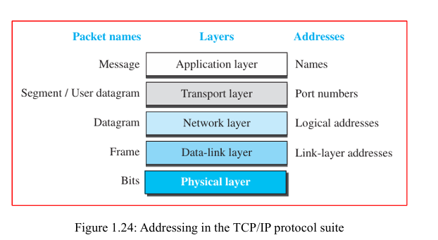
o Packet name: Segment (for TCP) or User Datagram (for UDP).
- Network Layer:
o The network layer uses global addresses, which are known as IP addresses (45.113.122.159). These uniquely identify a device's connection to the Internet and allow data to be routed across networks.
o Packet name: Datagram. 4. Link Layer: o At this layer, link-layer addresses (also known as MAC addresses 78-45-C4-29 17-E8) are used. These are local addresses that uniquely identify specific devices on a network (such as a LAN or WAN), ensuring that data reaches the correct physical machine.
o Packet name: Frame.
- Explain how identical objects interact with each other in TCP/IP protocol suite
Ans:
Layer in TCP/IP Suite | Identical Object / Peer Entity at Sender and Receiver | How They Interact
Application Layer | Processes / Sockets (e.g., HTTP client and HTTP server, or browser and web server) | Applications interact by exchanging messages or sockets identified by IP addresses and port numbers.
Transport Layer | TCP / UDP Modules (Transport-layer entities) | They break data into segments (TCP) or datagrams (UDP), adding port numbers and sequence numbers to maintain end-to-end reliability and flow control.
Internet Layer | IP Modules (Internet Protocol entities) | They package transport segments into packets (datagrams), attaching source and destination IP addresses to route data across interconnected networks.
Network Access / Link Layer | Network Interface / MAC Drivers (Ethernet, Wi-Fi drivers) | They encapsulate IP packets into frames, utilizing physical MAC/hardware addresses to move bits across the direct physical medium.
